**Ideation Phase**

**Ideation**

|  |  |
| --- | --- |
| Date | 15 October 2022 |
| Team ID | PNT2022TMID45285 |
| Project Name | IoT Based Gadget Child Safty Monitoring and notification |
| Maximum Marks | 4 Marks |

**Ideation to launch a child safety solution for schools, parents and children**

**There are huge protests across the city against the school and administration. These incidents have left parents of school going kids deeply concerned about the safety of their children who are not safe even in their schools. There is a constant fear in a parent’s mind while letting their children out of their sight.**

Help worried parents and kids who are left helpless in front of predators, Ideation Technology Solutions has come with a solution. We have built a device that can be with the kids at all times (in the form of a badge or pendant or band). When in trouble, kids can press the panic button on the device. At once, an alarm will ring in the school control room (this control room will be setup by Ideation) who can at once rush to help. Simultaneous alert will also reach the parent’s mobile as an SMS and app notification informing them on the whereabouts of their child. Parents can also track their kid’s location through the mobile app on their phones that will be linked to their **child.,**

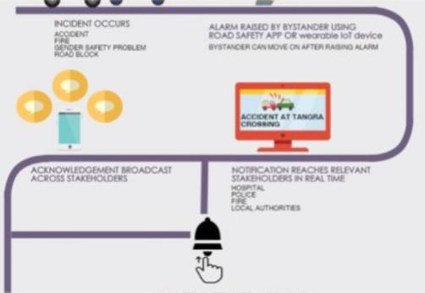

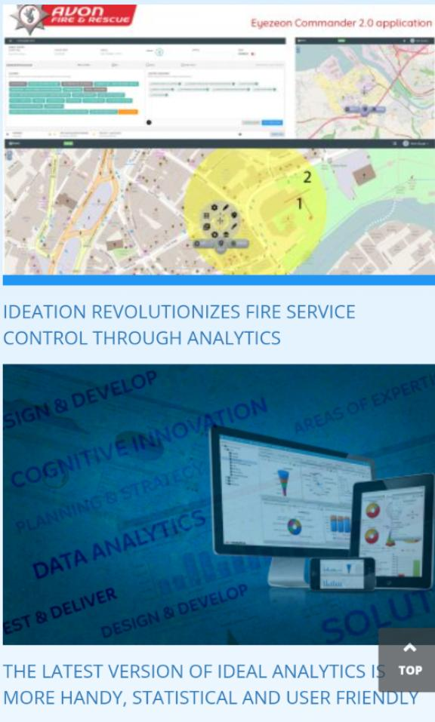

**The designer and the engineer**

The relationship between technology and design is not always an easy one. Going beyond software and adding connected hardware to the mix makes things even more difficult. IoT can be very abstract and technical, making it difficult for projects stakeholders to have a common understanding about a concept..

The success of a service that involves an IoT related technology is based on a fine balance between technological possibilities and great user experience. In order to achieve this balance, Engineering and Design need to be aligned, speak the same language and understand and contribute to each other’s disciplines. Therefore, more than ever, collaboration between tech and design is essential..

IoT is about designing systems

A crucial understanding when design IoT products, is that you are designing a system. This system consists of an interplay between people, objects and environments. The difficult thing to keep track of in an IoT context, is the actions that happen on a physical and digital level. This is even more so during the early phases of a design process, when a lot of design..

The workshop progress

During Thingscon Amsterdam, Ricardo and Dries organised two workshops. During each workshop, five team teams of four to six people got the opportunity to try out both the IoT service kit and IoT ideation cards. Each workshop session consisted of three parts:

Problem definition

In a real project context, the problem space is often very well defined. For instance, this can be based on own analysis, existing client brief or business opportunity. However, in this workshop setting, we used several random elements to come up with a problem statement.

IoT Service Kit story creation

In order to flesh out the problem statement, the IoT service kit was used to create an underlying story and facilitate the service development to solve it. With the IoT Service Kit participants were able to create a full user journey through and create a story around the service.

IoT Ideation cards system mapping

Once story was created, the IoT ideation cards were used to synthesise the resulting IoT system. This means that cards were created for all persons, objects and environments that are part of the generated concept